Accessibility Guide for Pennlyon
marjoriefeast@yahoo.co.uk, 01527 893619, pennlyon.co.uk
Contact for accessibility enquiries: Mrs MC Feast
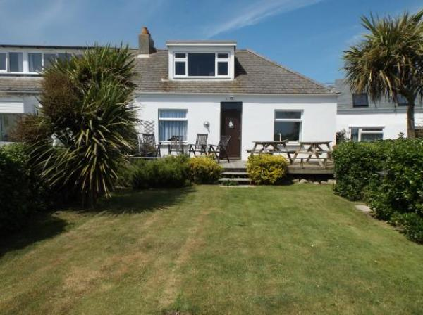

Welcome
Pennlyon is a beachside, end terrace, self-catering bungalow for 4, looking south over Porthcressa bay, in Hugh Town. It is close to all town facilities.

At a Glance

Level Access
- The main entrance has 3 steps. There is no lift and no ramp.
- There is level access from the main entrance to:
  - Lounge
  - Bathroom

Access with steps
- There are steps from the main entrance to:
  - Pennlyon

Level access bedrooms
- The route to the bedroom is 750mm wide, or more.
- The bedroom door is 750mm wide, or more.

Getting here
Pennlyon, 1 Little Porth
Hugh Town
St Mary's, Isles Of Scilly
TR21 0JG

Travel by public transport
- You can get to Pennlyon by boat or ferry.
- The nearest port is St Mary's. The port is 1 miles / 1.6 km from Pennlyon.

Parking
- We have a car park. The parking is less than 50 metres from the main entrance. Parking is free.
- From the parking to the main entrance, there are 3 steps. There is no ramp and no lift.

Arrival

Main entrance
- The main door is side hung and manual.
- The door is 830mm wide.
- The main entrance has 3 steps.

Getting around inside

Bedrooms
- All bedrooms have windows.
- Bedrooms have ceiling lights, bedside lamps, desk or table lamps and natural daylight.
- Lights are LED and energy saving. All bedrooms are non-smoking.
- All bedrooms have fitted carpets.
- The direction of transfer onto the toilet is to the front only.
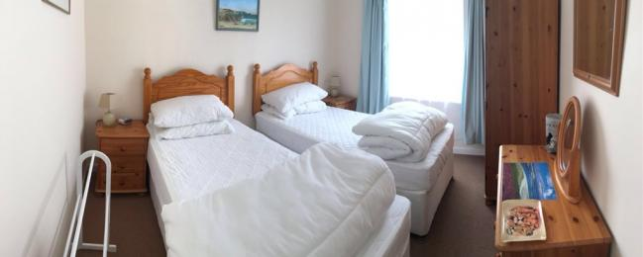
Twin Bedroom
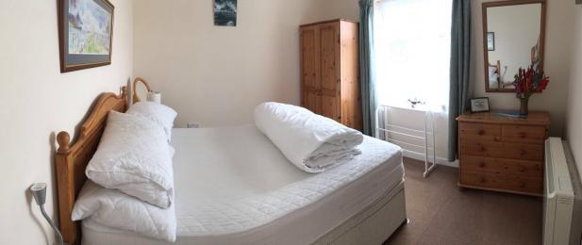
Double Bedroom

Self catering kitchen

Kitchen
- We have a separate kitchen and dining room. From the main entrance to the kitchen, there is level access.
- The route is 830mm wide, or more.
- From the main entrance to the dining room, there is level access. The route is 760mm wide, or more. The door is 750mm wide.
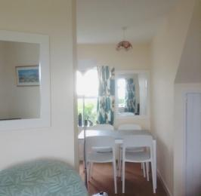
Dining Room
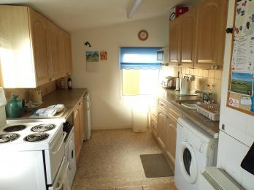
Kitchen

Lounge

Lounge
- From the main entrance to the lounge, there is level access. The route is 760mm wide, or more. The door is 750mm wide.
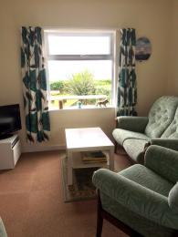
Lounge

First Floor Leisure Room
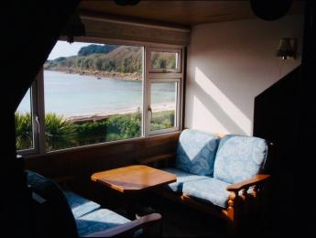
First Floor Leisure Room

Bathroom
- From the main entrance to this area, there is level access. The route is 530mm wide, or more.
- The door is 530mm wide.
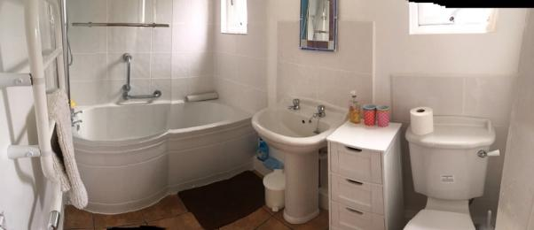
Bathroom - the only one in the property.

Getting around outside

Pennlyon
- From the main entrance to the area, there are 3 steps.

Customer care support

Guide last updated: 18 March 2019

